**Tên: Nguyễn Như Khoa**

**MSSV: 31211025536**

**Lab 3-1**

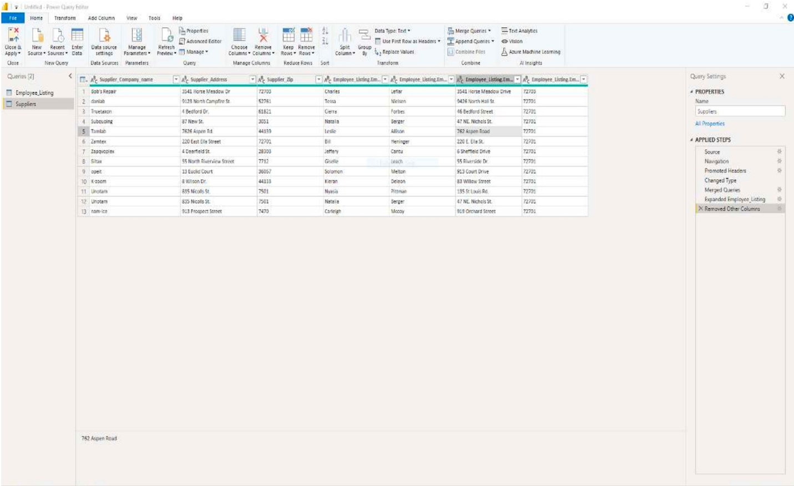

**3-1MA**

**3-1MB**

**OQ1:** I got Bobs Repair as the best match for Slainte

**Lab 3-2**

**3-2MA**

**3-3MA**

**OQ1:** When we Place our cursor over the data point in the top-right cluster of your cluster analysis tool to see the interest rate associated with that particular value. The precise interest rate may change based on the dataset you use.

**OQ2:** Loans in the bottom-left cluster should typically have interest rates that are closer to 6%. But, you ought to verify this by examining the real data points contained in that cluster.

**OQ3:** You must count the cluster in your cluster analysis results that satisfy this requirement in order to ascertain the number of clusters that have five or more distinct interest rates assigned to them.

**Lab 3-3**

**3-3MB**

**3-3MC**

**OQ1:** It is 0.6424 which meansthe regression model explains 64.24% of the variation in the college completion rate

**OQ2:** The correlation coefficient between the two variables is 0.8015, indicating a strong positive correlation, suggesting that the SAT average can indeed predict the college completion rate.

**OQ3:** We can use the regression model to predict a student's likelihood of finishing college if they have a SAT score of 1100.

The regression model's equation is as follows:

= - 0.57417 + 0.00106 * SAT average

Upon entering a SAT score of 1100, the anticipated college completion rate is as follows:

= - 0.57417 + 0.00106 * 1100 = 0.5918

Consequently, the likelihood that a student with a SAT score of 1100 will graduate from college is 0.5918.

**Lab 3-4**

**3-4MA**

**3-4MB**

**OQ1:** ORIG_PRICE

**OQ2:** 2195

**OQ3:** 3699

**Lab 3-5 Part 1:**

**3-5MA**

**OQ1:** 3699

**OQ2:** 698

**OQ3:** 14.99

**OQ4:** 17

**Lab 3-5 Part 2:**

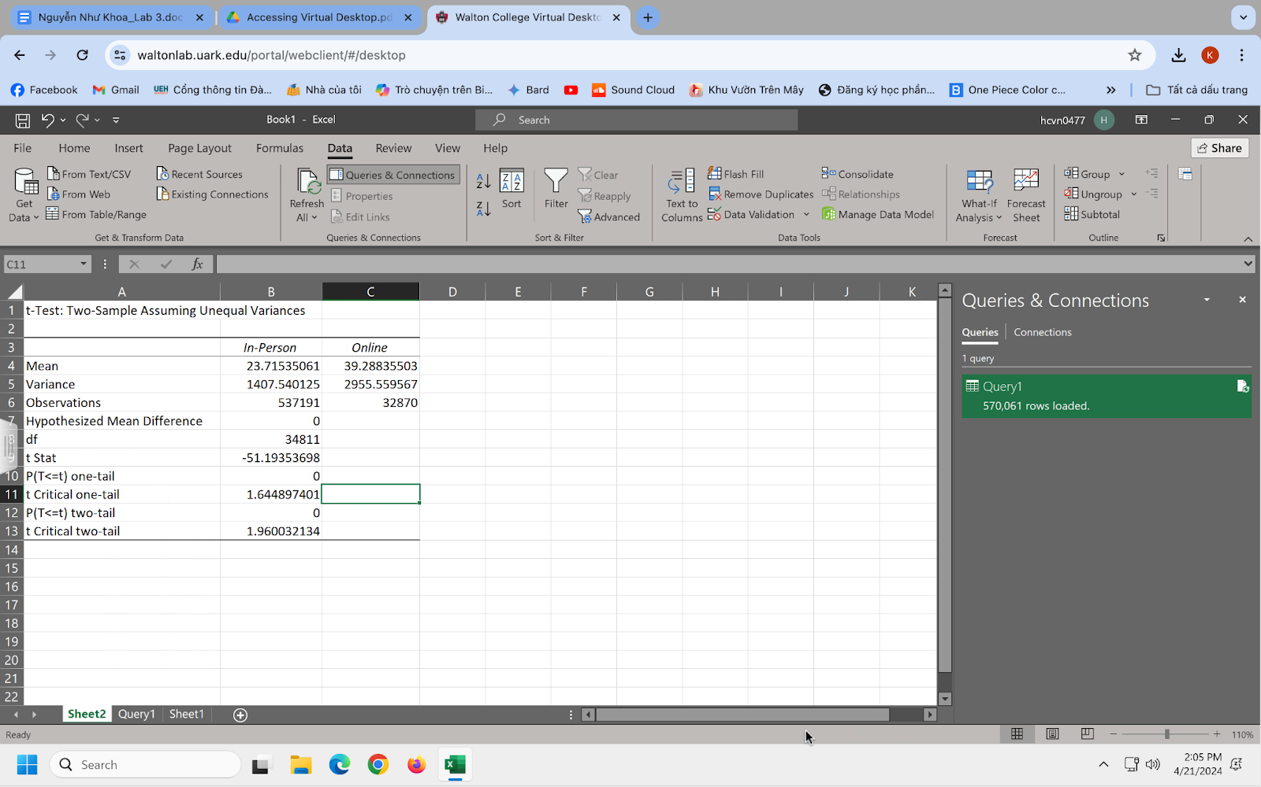

**3-5MB**

**OQ1:** The p-value for the one-tailed test is given as 0

**OQ2:** Reject, because the p-value is less than 0.05 significance level. If the p-value is less than 0.05 significance level, we reject the null hypothesis. If the p-value is greater than 0.05 significance level, we fail to reject the null hypothesis

**Lab 3-6 Part 1:**

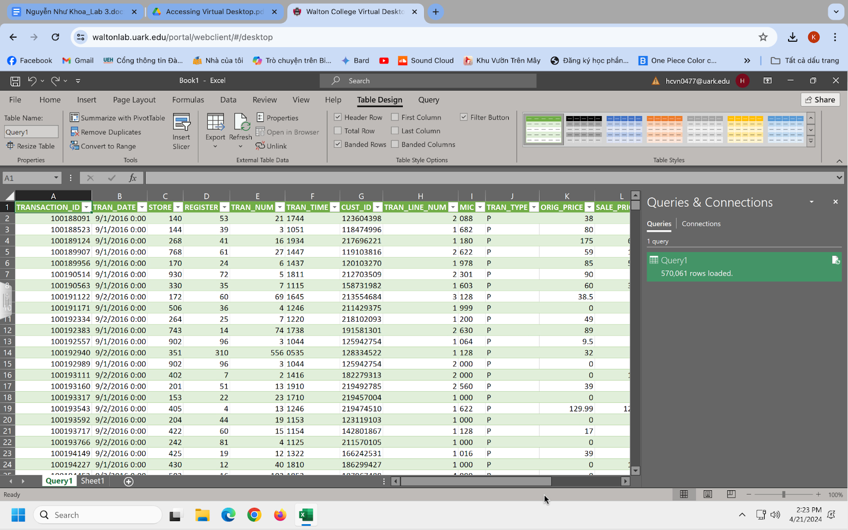

**3-6MA**

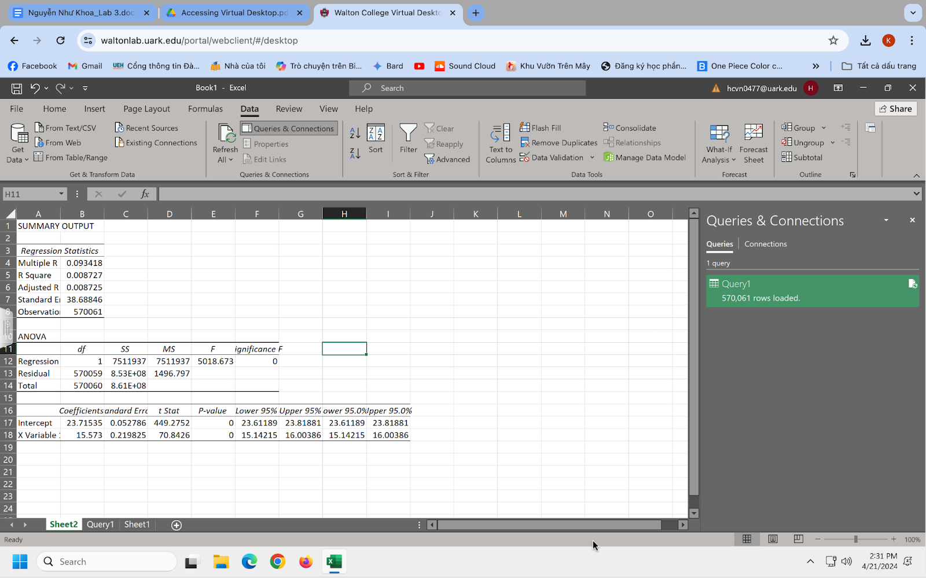

**3-6MB**

**OQ1:** TRAN_AMT = 15.573*Online-Dummy + 23.71535

**OQ2:** 0.008727

**OQ3:** The p-value provided for the explanatory variable is 0

**OQ4:** The Significance F value is 0

**Lab 3-6 Part 2:**

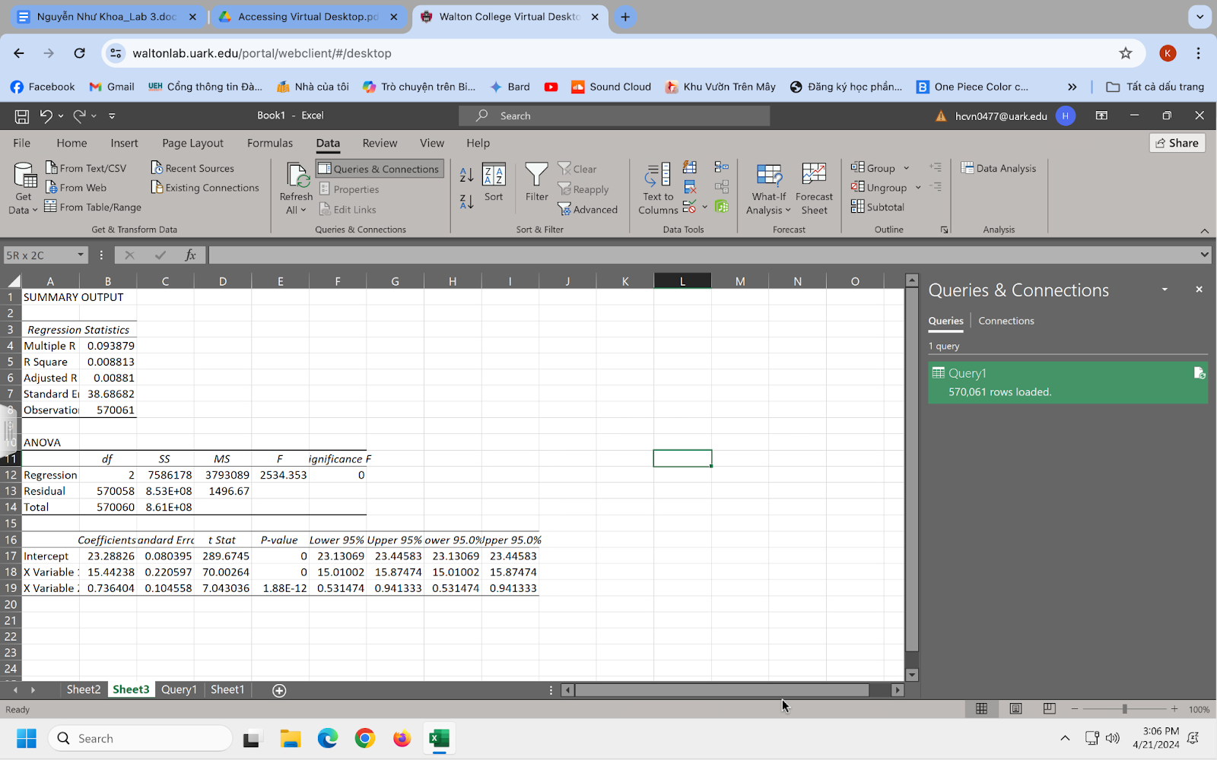

**3-6MC**

**OQ1:** 0.736404

**OQ2:** 15.44238

**OQ3:** 23.28826